OS Lab 1
Q1:
- Apt-get:
Command line package manager for Debian-based Linux systems to install, update, and remove software.
- Yum:
Package manager for RPM based Linux systems that installs and manages softwares with dependency handling.
- Wget:
Command line tool used to download files from the internet.
- Gzip tar:
Gzip compress files, while tar combines multiple files into a single archive ( .tar.gz).
- Rar:
A file compression and archiving tool that creates and extracts .rar archives.
Q2:
Show architecture of machine:
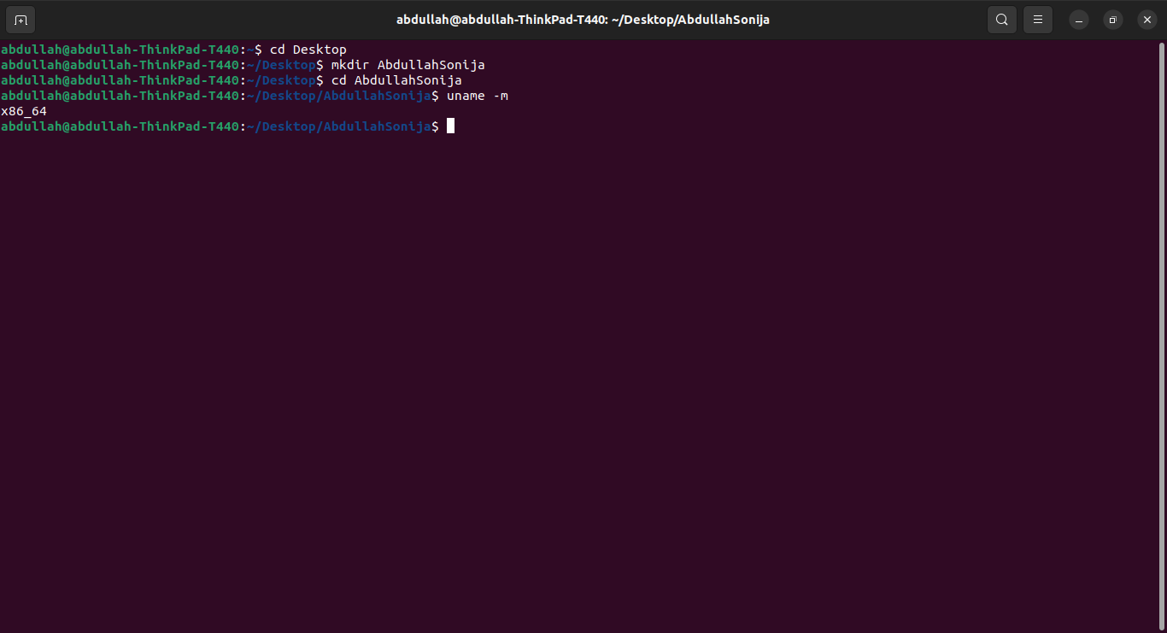
Show CPU info: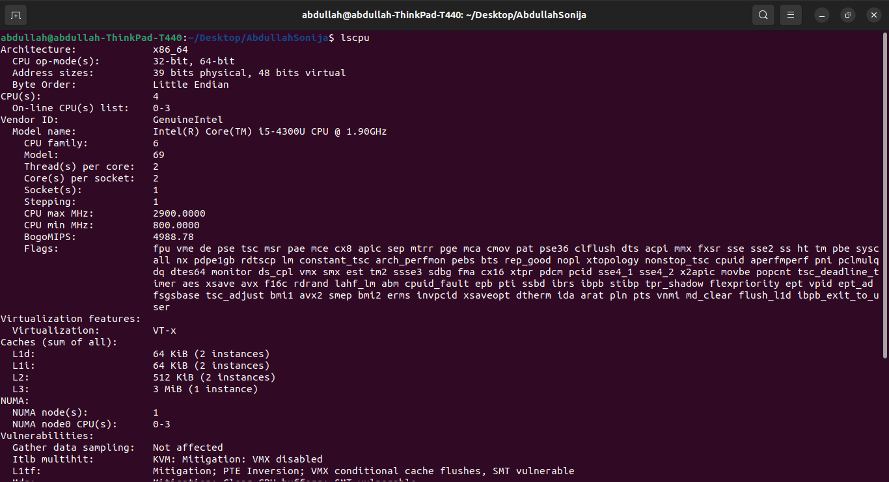
Show version of the kernel
Show system date
Set date and time
Show details of files and directories
Show hidden files
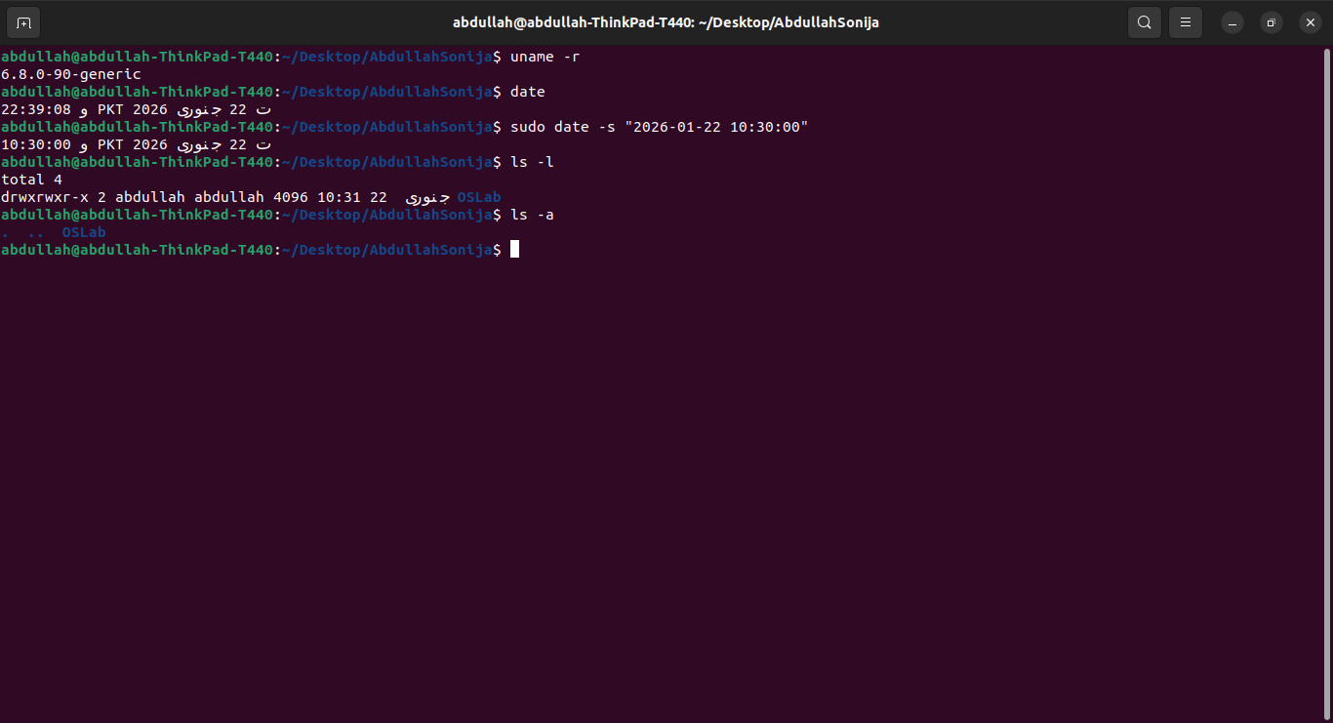

Show files & directories containing numbers (shows error because no such file exists)
Create a directory called dir1
Create two directories simultaneously
Show path of working directory
Delete file called file1
Remove directory dir1 with contents
Delete empty directory dir1 (already deleted -> shows error)
Modify timestamp of file/directory
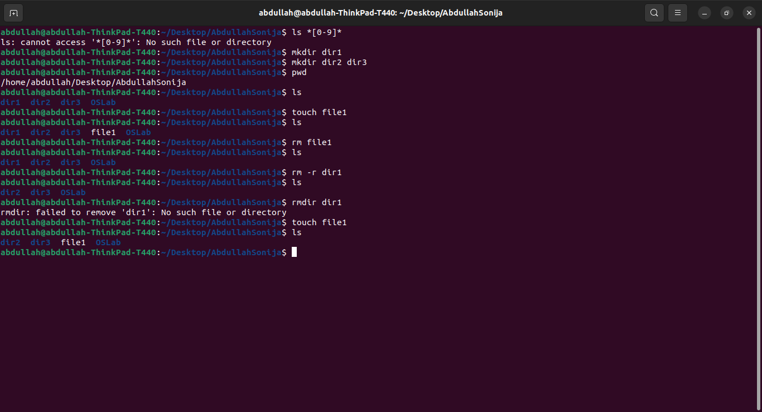
Q3:
I set up Ubuntu as the primary operating system on my laptop rather than VirtualBox.

